**Step 1.** Create a folder called **“CiscoCRMIntegration”** under **C:\\** drive

**Step 2.** Place the two files: **SearchCRM.exe** and **SearchCRM.exe.config** under the **“C:\\CiscoCRMIntegration”** folder.

**Step 3.** Right click on the **SearchCRM** exe file select Properties. Under security check unblock and click **Apply** or **OK**.

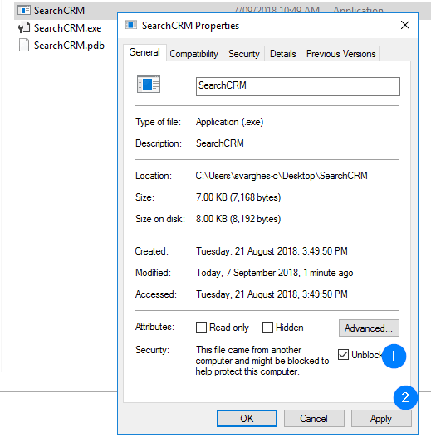

Done!!

When the file is opened the first time, you may see a pop-up from the antivirus. Click allow this file.

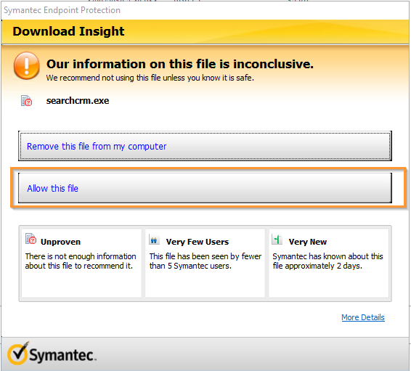

Click OK on the confirmation Pop-up

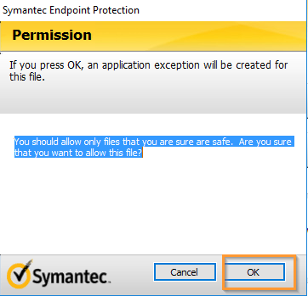

When the CRM application is already open during an incoming call, you may see a prompt that looks like the below:

Click Yes to accept the search. Click no to continue working.

